* Fingerprint Modeling
  + Ride pattern in local area of a fingerprint can be approximated by a cosine wave
    - w(x,y) = Acos( 2pi\*f( xcos(theta) + ysin(theta) ) )

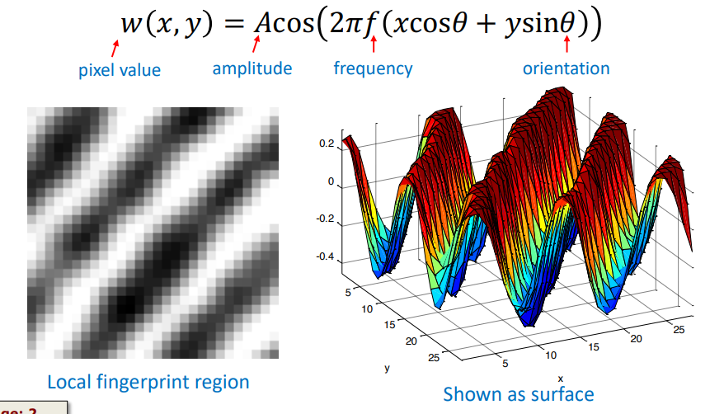

* 2 Methods to compute orientation field
  + 1: Based on Fourier Transform applied to the local region
  + 2: Based on filtering the image using edge detection filters

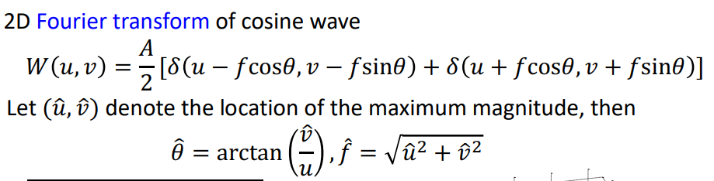

* Edge Detection
  + Image flyers can be used to detect edges in an image
  + An edge correspond to a collection of pixels
  + The Pixel intensity changes sharply across the edge
    - An edge may correspond to the boundary of an object
    - In the case of fingerprints, the contours of the ridges may be viewed as “boundaries”
  + The magnitude of the gradient or difference in pixel intensities in the neighborhood of a pixel can help in detecting edge pixels.
* Gradient = difference of changes
  + Computed in horizontal and vertical directions.

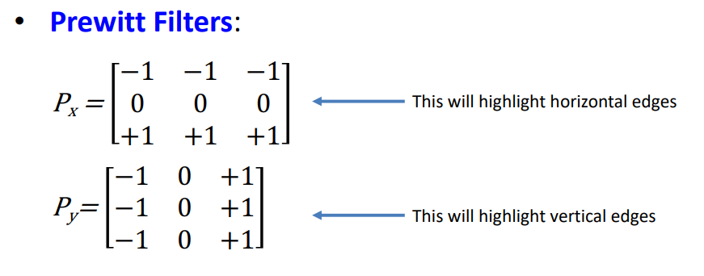

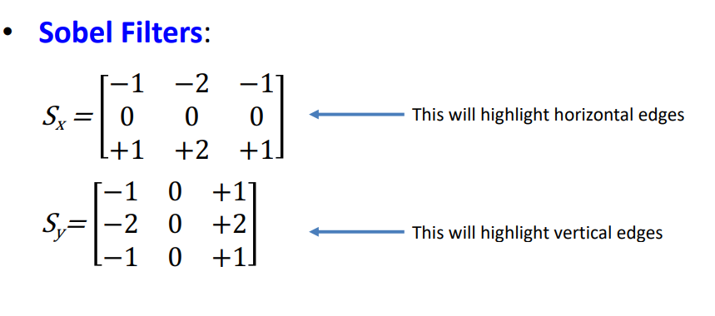

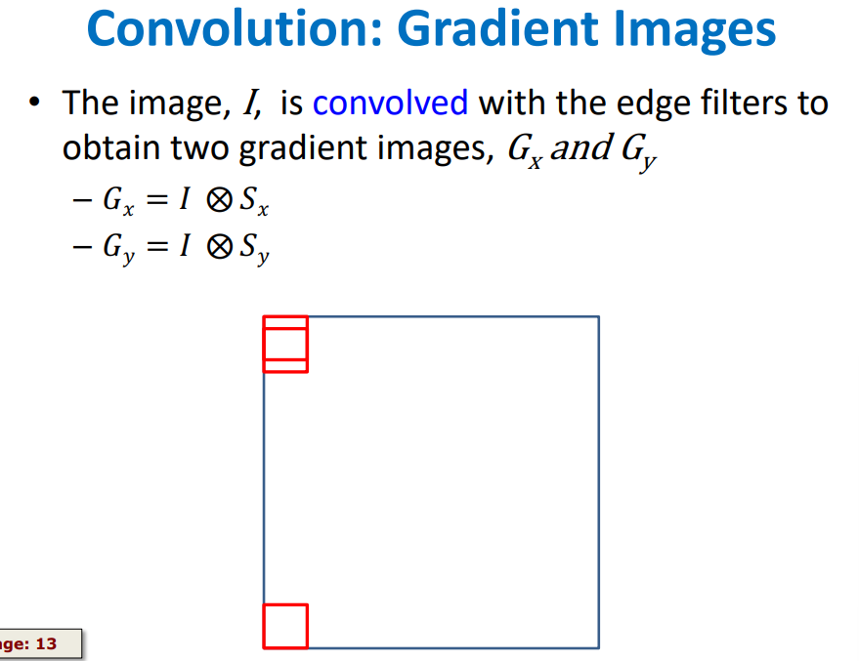

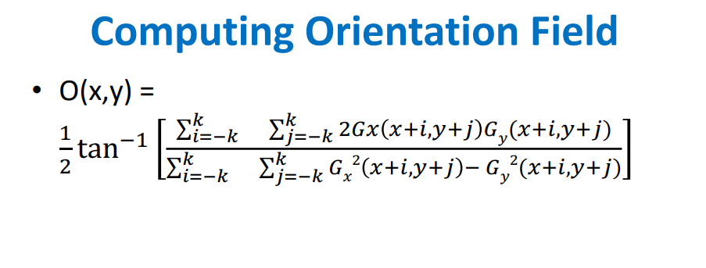

* First apply the two filters independently on the image
* Based on the two filtered outputs, compute the orientation at a pixel
* 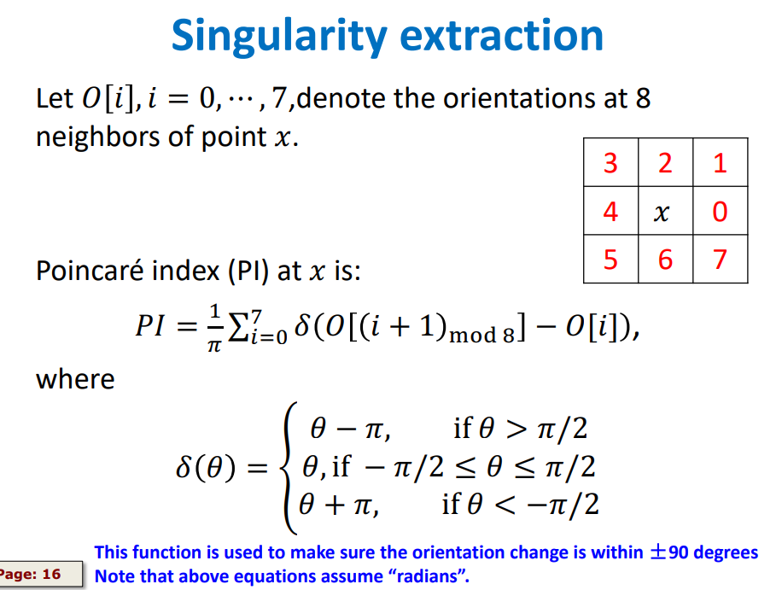

Pattern Classification

* We can classify a fingerprint int one fo 6 major pattern types based on singular points(SP)
  + Plain arch: contains no SP
  + Left loop: contains 1 delta and 1 loop whose direction points to the let side of the delta
  + Right Loop: contains 1 delta and 1 loop whose direction points to the right side of the delta
  + Tented arch: contains 1 delta and 1 loop whose direction points toward the delta.
  + whorl: contains at least 2 loops and 2 deltas where ridge orientation field around the two loops form a circular orbit.
  + Twin loop: contains at least 2 loops and 2 deltas where the ridge orientation field around the two loops do not form a circular orbit.